Easy Read information about our

Accessibility Policy
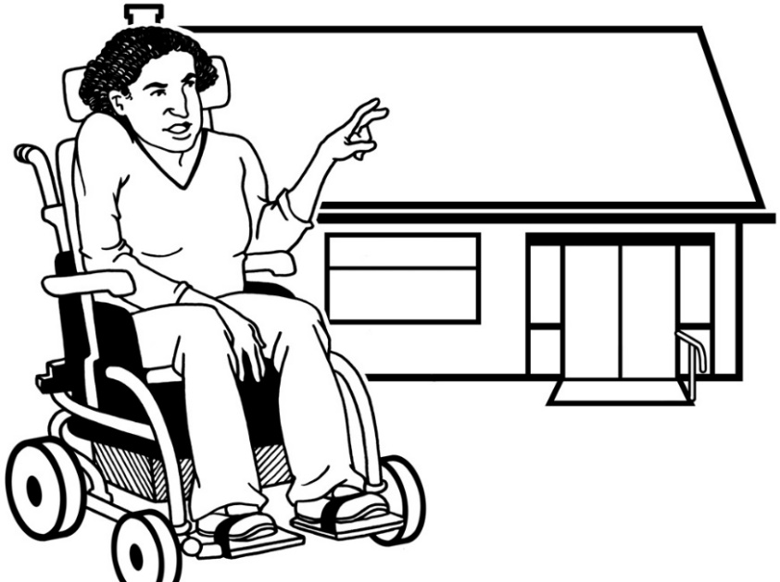

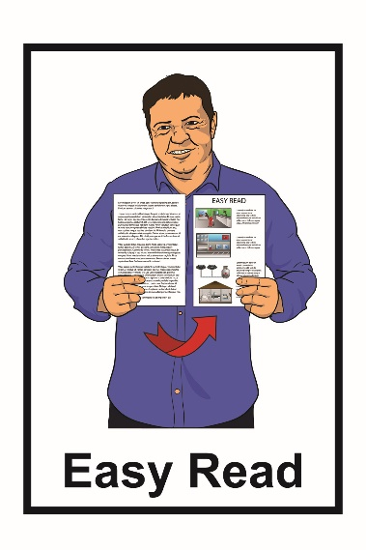
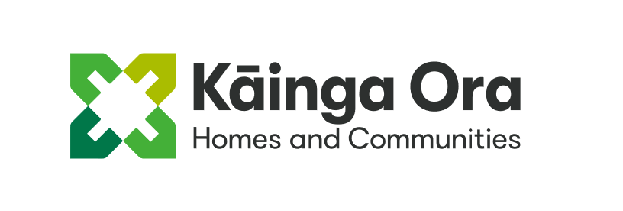
How Kāinga Ora will make more accessible homes

What is in this book?

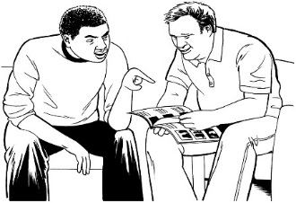
Page
Before you start 4

Who is Kāinga Ora? 6
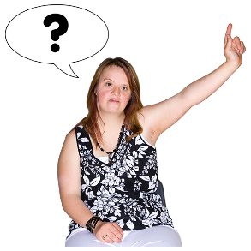

What is this document about? 7
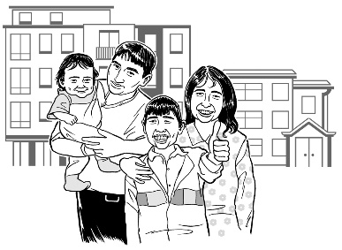

Accessible homes are important 10

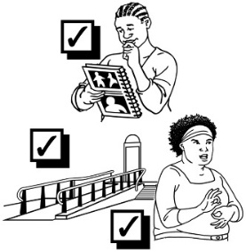
What do we mean by accessible? 12

Page
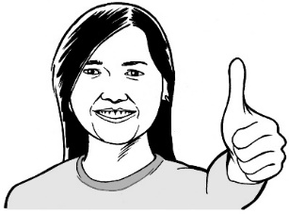
How we want to work 16

What do we know about
what our tenants need? 24

Things we want to happen 26

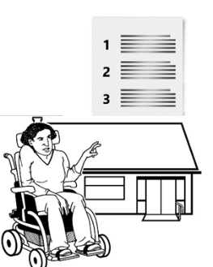
1. More of our homes meet
our Universal Design standards 28

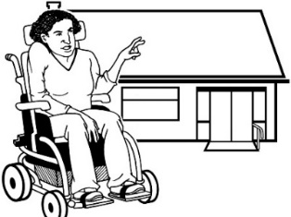
2. Meet the different needs of
each tenant 32

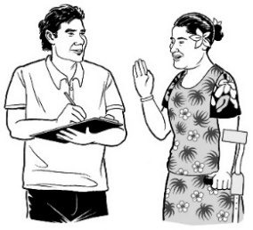
Page
3. Get better information 37

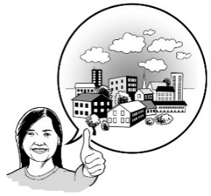
What you will see 41

What happens when? 44

Get in touch 47

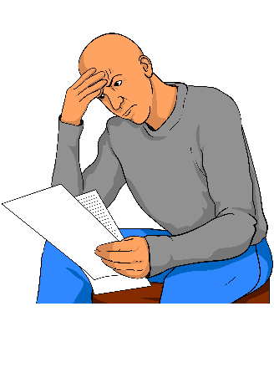
Before you start

This is a long document.

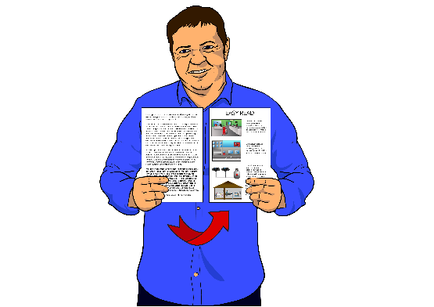
While it is written in Easy Read it can be hard for some people to read a document this long.

Some things you can do to make it easier are:

- read it a few pages at a time
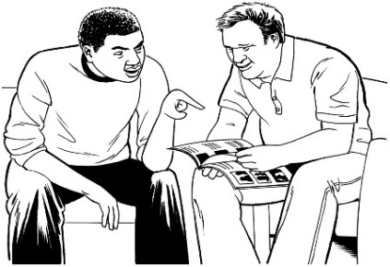
- have someone assist you to understand it.

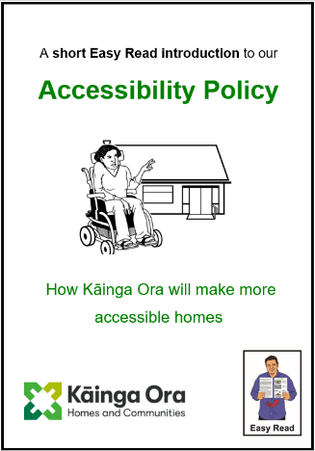
There is also a shorter document about our Accessibility Policy.

You can find the shorter document on our website:

https://kaingaora.govt.nz/news/new-kainga-ora-accessibility-policy/

Who is Kāinga Ora?
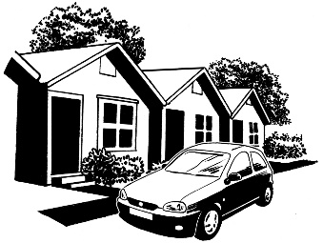
Kāinga Ora is the new government agency that works on housing.

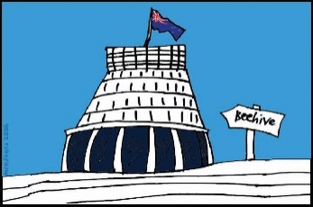
A government agency is a group that does work for the government.

Kāinga Ora does the things that Housing New Zealand used to do like:
- building homes

- owning homes
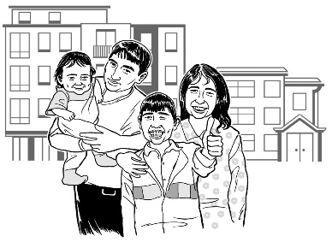
- renting homes to people who need them.

What is this document about?
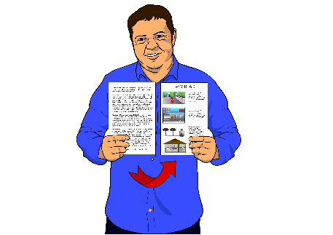
This document has Easy Read information about the Kāinga Ora Accessibility Policy.

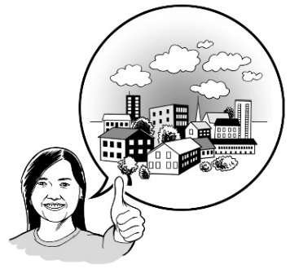
Our Accessibility Policy says how we will work to make the homes we rent out more accessible.

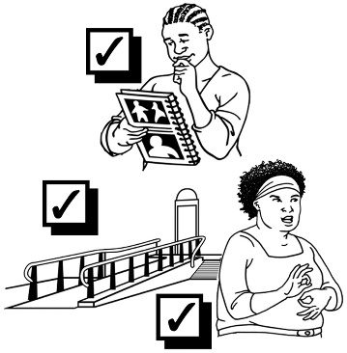
If something is accessible it means people with disabilities are able to use it.

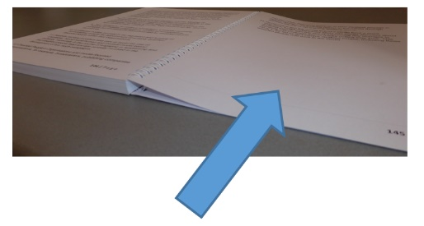
You can read more about what we mean by accessibility on page 11.

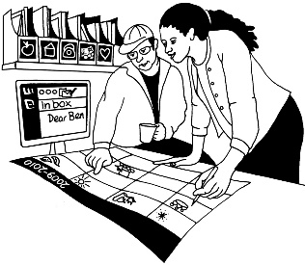
We have made this plan by talking to:

- people who work for Kāinga Ora

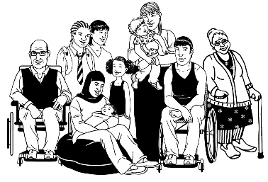
- disabled people who live in Kāinga Ora homes

- other people that our work affects.

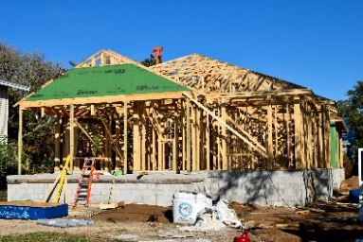
The work we will do includes:

- building new homes
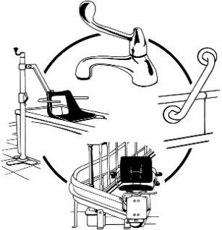
- changing old homes to make them more accessible.

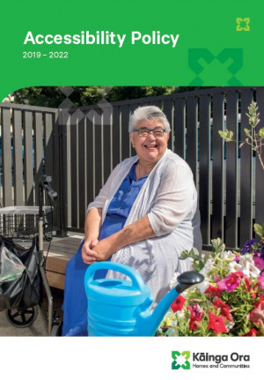
If you want to find out more you can find our full Accessibility Policy on this website:

https://kaingaora.govt.nz/news/new-kainga-ora-accessibility-policy/

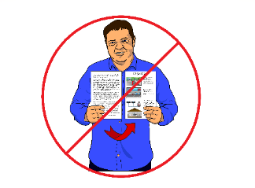
Our full Accessibility Policy is not in Easy Read.

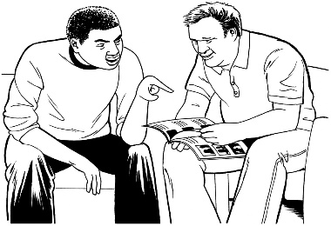
You may need someone to assist you to read it.

Accessible homes are important
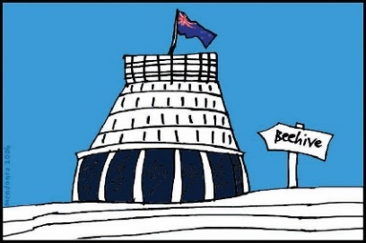
It is important to the Government to make homes in New Zealand more accessible.

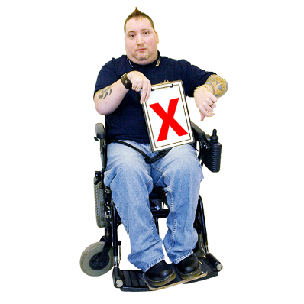
Not having accessible homes is one of the biggest things making life hard for disabled New Zealanders.

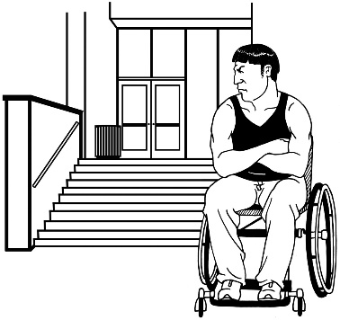
We know that if a home is not accessible the people who live there:

- have a worse life
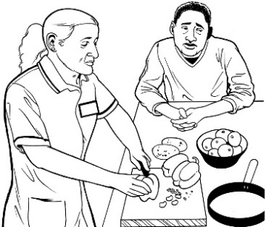
- cannot do things that they could do in a different home.

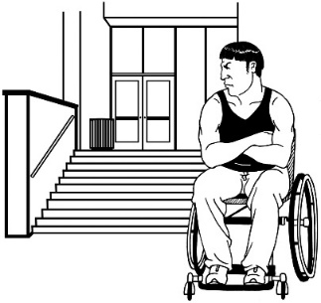
We call a house disabling if it stops someone from doing things they could do in a different house.

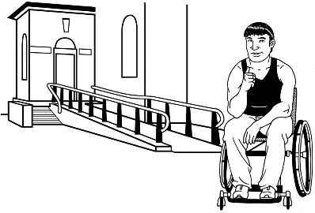
It is important to understand that the house is causing problems not the person who lives there.
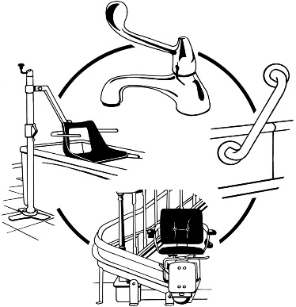

Houses can be changed.

What do we mean by accessible?
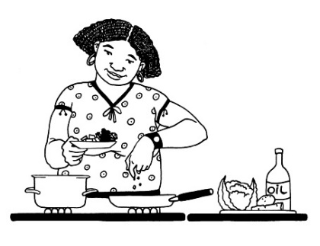
Kāinga Ora thinks an accessible home should make it easy:

- to live with independence
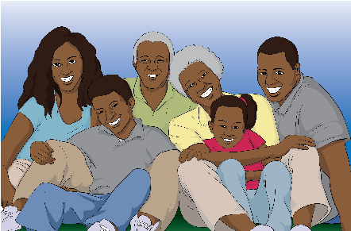
- to live with dignity

- to have family / whānau and friends visit
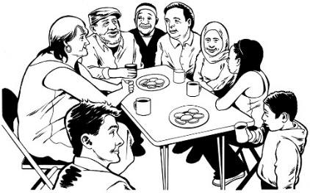
- to be part of the community

- to be safe.
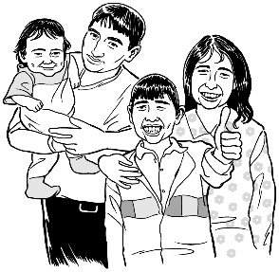

Living with dignity means living in a way that makes it easy to have:

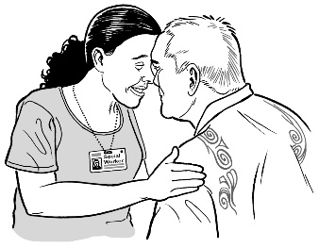
  - respect for yourself

  - respect from others.
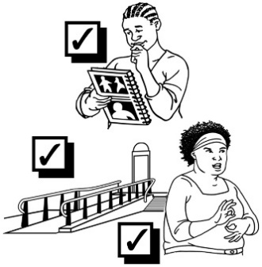
Kāinga Ora uses Universal Design as a way to make housing accessible.

Universal Design is about making things accessible for as many people as possible.

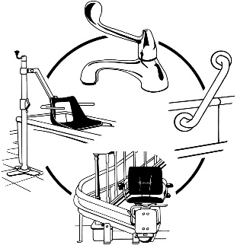
Universal Design is also about making things that can be changed if they need to be.

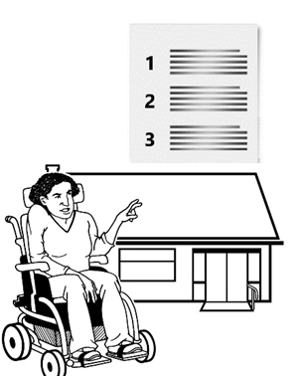
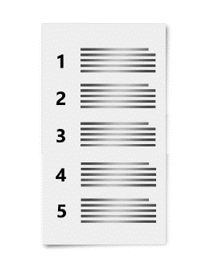
Using the idea of Universal Design we have made a list of things that make a home accessible.

The things on this list are our Universal Design standards.

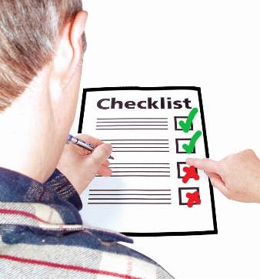
All the new homes we build will meet some of our Universal Design standards.

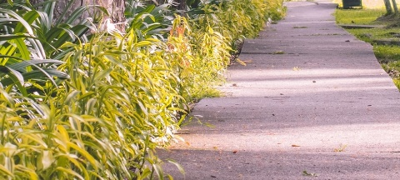
For example all the new homes built by Kāinga Ora will have:

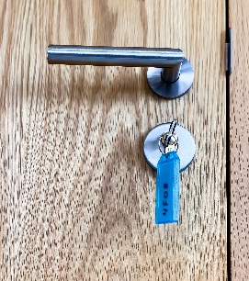
- wide concrete paths

- wide hallways

- door handles that are easy to use
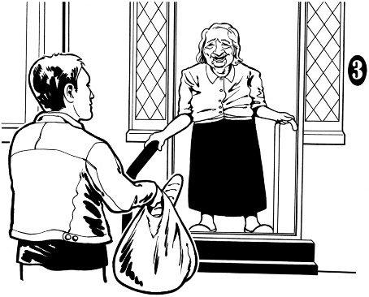
- non-slip floors

- a handrail if there are steps.

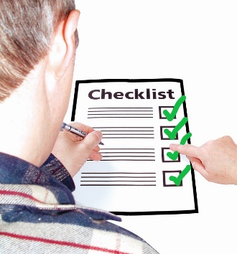
Some of the new homes we build will meet all of our Universal Design standards.

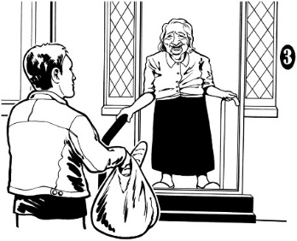
These homes will have all the things the other homes have.

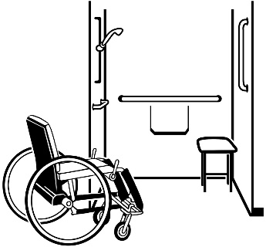
They will also have things like:

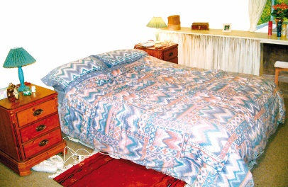
- a bathroom on the same floor as the front door

- a bedroom on the same floor as the front door

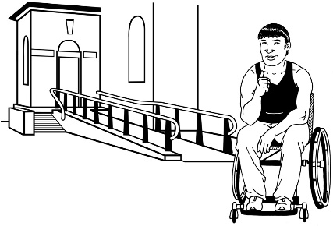
- space for a ramp to be added if there are any stairs.

How we want to work

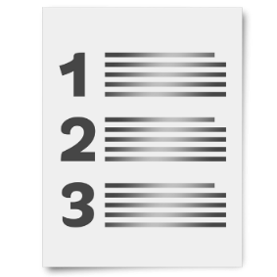
This is a list of commitments that Kāinga Ora has made.

Our commitments are things that:
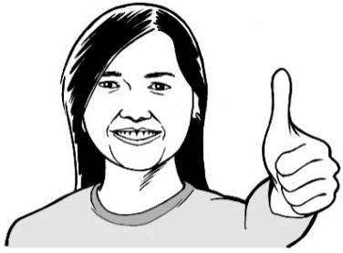
- we say we will do

- are important to us.

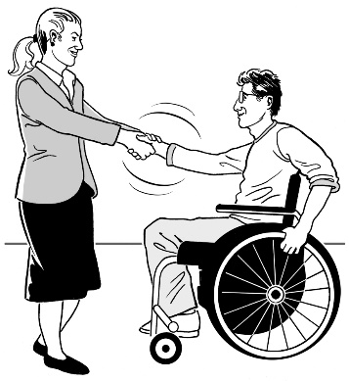
We will think about our commitments when we are deciding:

- how to do our work

- how we work with our tenants.

The people who rent homes from Kāinga Ora are called our tenants.

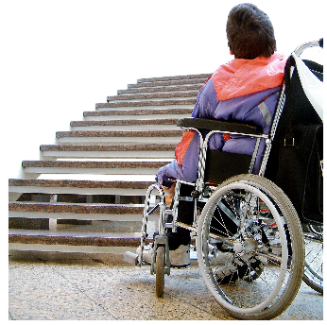
Our commitments

- We understand that it is important to:

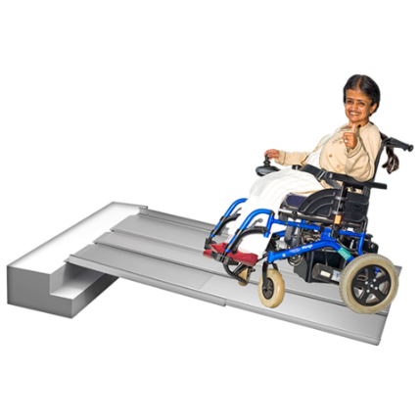
- find the barriers faced by all disabled people

- take away these barriers.

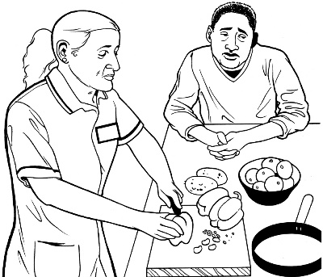
Barriers are things that:

- get in the way

- make it harder to do the things we need to do.

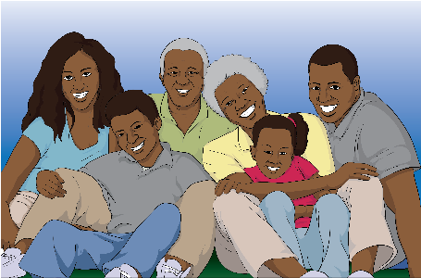
- We know that we will make things more accessible if we remember how important every person is to their:
- family

- community.

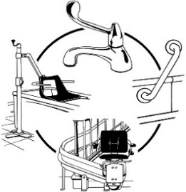
- We will look at all kinds of ways to meet the needs of our tenants.

This is so our tenants can:
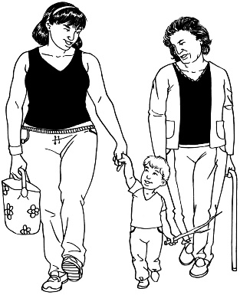
- live with dignity

- live independently for as long as possible.

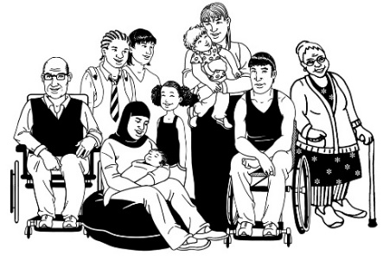
- We will help communities to include all different people.

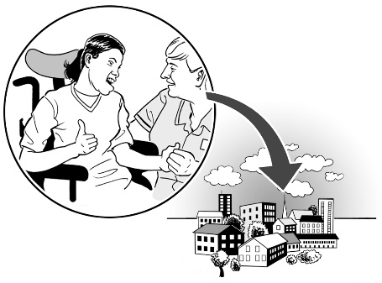
- We will change things about our housing that make it hard for tenants and their whānau to take part in the community.

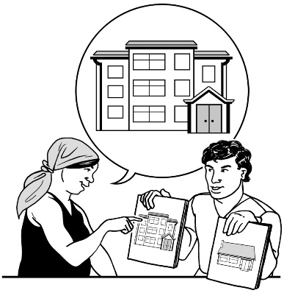
- We will make accessible homes that are:

- different kinds of homes

- in different kinds of places.

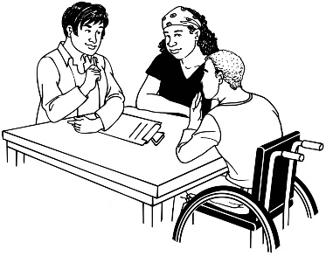
- We know that disability organisations do important work in communities.

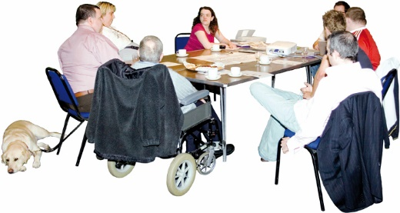
We will talk to disability organisations.

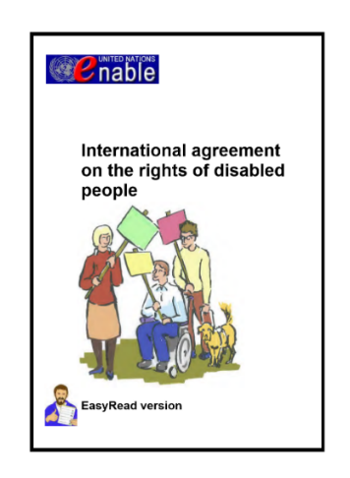
- There are things that we must do to follow the United Nations Disability Convention.

The Disability Convention says:
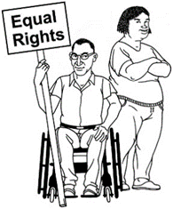
- how disabled people should be treated

- what governments need to do to make sure disabled people get their rights.
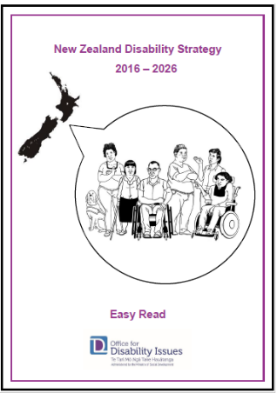
There is more information about how New Zealand plans to follow the Disability Convention in:

  - the New Zealand Disability Strategy 2016 - 2026
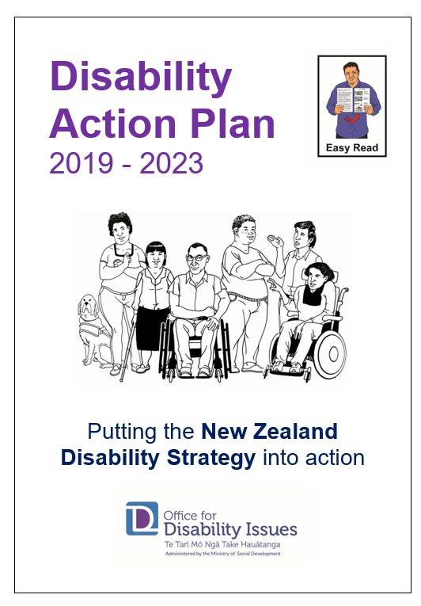
and

  - the Disability Action Plan 2019 - 2023.

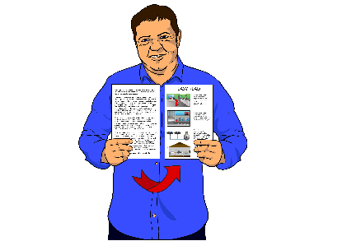
These plans are both in Easy Read.

You can find the New Zealand Disability Strategy at this website:

https://www.odi.govt.nz/assets/New-Zealand-Disability-Strategy-files/pdf-easy-read-nzds-2016.pdf

You can find the Disability Action Plan at this website:

https://www.peoplefirst.org.nz/download/2772/

What do we know about what our tenants need?
At the moment Kāinga Ora does not have a way to get all the information we need about:

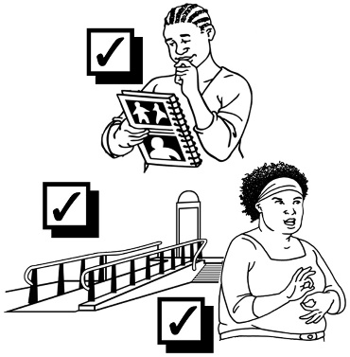
  - our tenants

  - their whānau

  - their access needs.

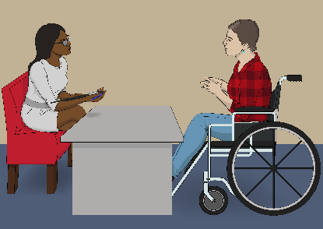
Most of the time we find out about access needs when someone moves into a Kāinga Ora home.
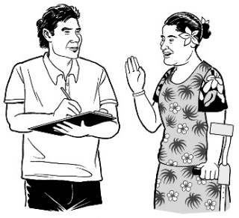
But we do not ask again later to find out if their needs have changed.

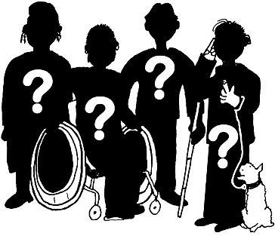
So the information we have is missing out the needs of many tenants.

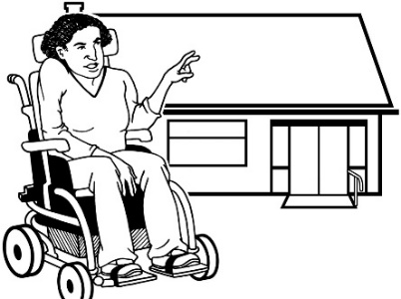
We need better information to help us:

- meet the needs of each tenant
- understand the needs our housing will have to meet in the future.

Things we want to happen
We have 3 main outcomes.

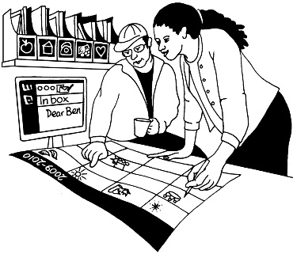
Outcomes are the things we will work to make happen.

Outcome 1

More of our homes meet our Universal Design standards.

Outcome 2

Meet the different needs of each tenant.

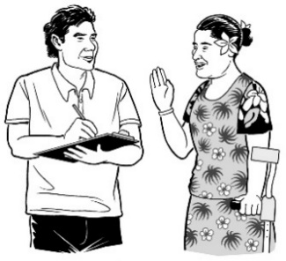
Outcome 3

Get better information:

- What do our tenants need?
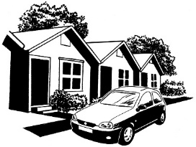
- How accessible are the homes we rent out?

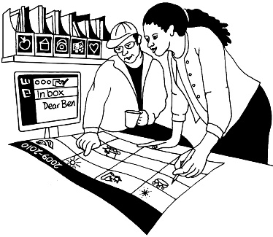
On the next pages we say what work we will do to make each outcome happen.
- More of our homes meet Universal Design standards

Universal Design standards
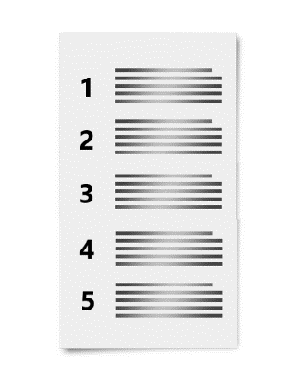
We have a list of things that will make a home accessible.
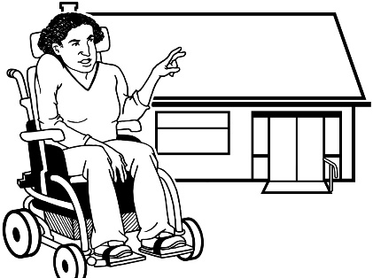
Universal Design standards are the things on this list.

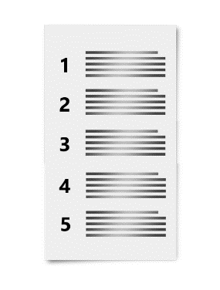
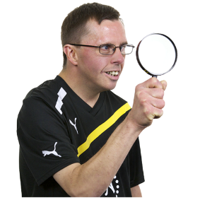
We will look at our Universal Design standards to see if anything needs to change.

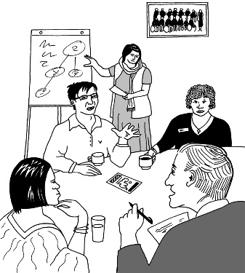
We will explain our Universal Design standards to the people who need to use them.

Building new homes
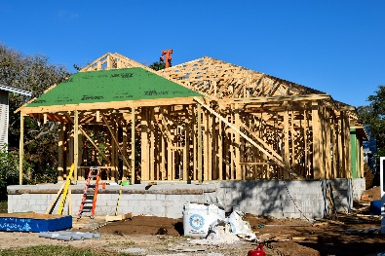
We will make more new homes that meet our Universal Design standards.
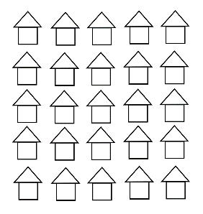
We will say how many of our new homes will meet all the Universal Design standards.

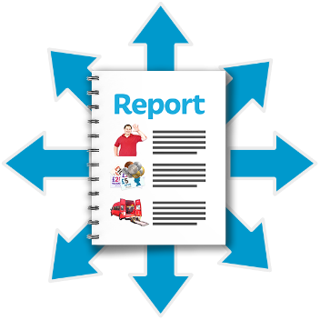
Then we will let people know if we made this many new homes.

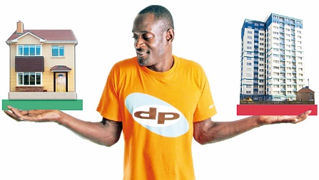
We will make sure that we make different kinds of homes that meet the Universal Design standards.

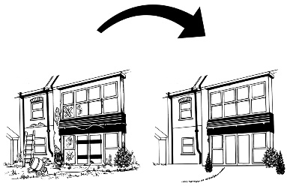
Homes we already have

Many of the homes that Kāinga Ora rents out need work done on them.

When we work on these homes it will be a chance to make them more accessible.

We want to find out:

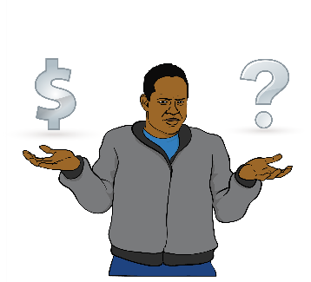
- How hard is it to make these homes meet our Universal Design standards?

- How much money will it cost?

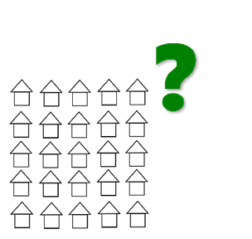
When we have answers we will make a plan that says how many homes we will make more accessible.

- Meet the different needs of each tenant

Modifications to a Kāinga Ora home

Modifications are changes that make a home more accessible.

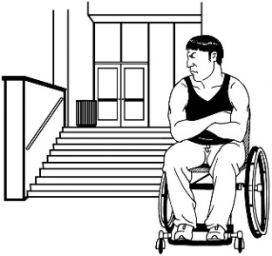
When a tenant needs modifications to their home we assist them to ask for money from:
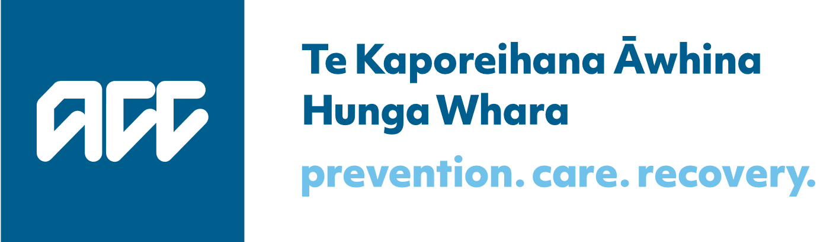
- ACC

or
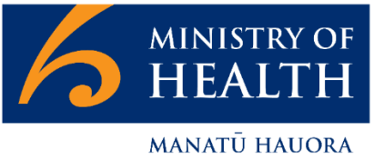
- the Ministry of Health.

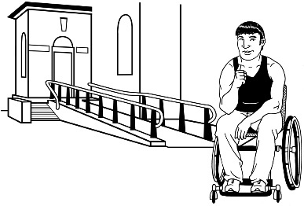
Then Kāinga Ora make the changes.

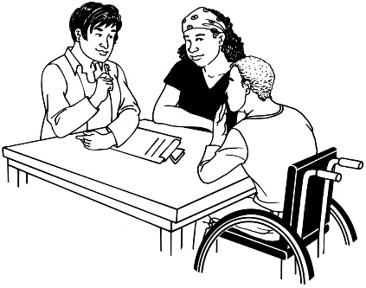
We will work with ACC and the Ministry of Health to make it easier to ask for money for modifications.

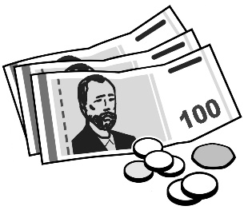
We will also look into ways that Kāinga Ora can pay for modifications.

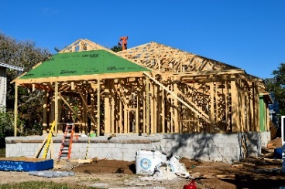
Sometimes the best thing is for a tenant to move into a new home that is made to meet their needs.

Homes for groups of people with the same needs
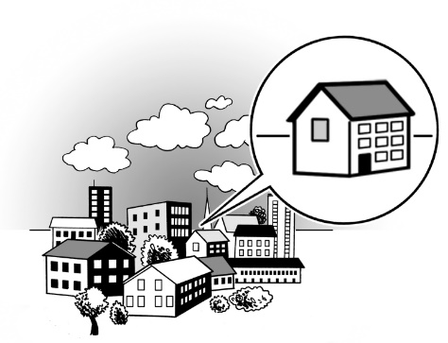
Kāinga Ora rents out some of our homes to other organisations to use for Community Group Housing.

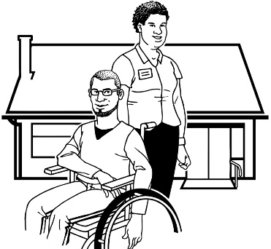
Community Group Housing is for groups of people like:

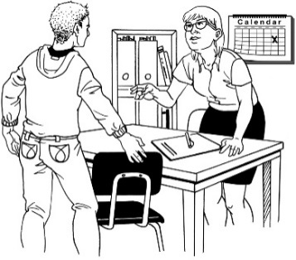
- disabled people who need assistance

- young people who need extra support
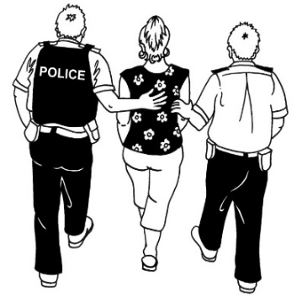
- people who have just got out of prison.

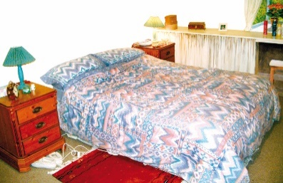
Community Group Housing can be:

- somewhere people live
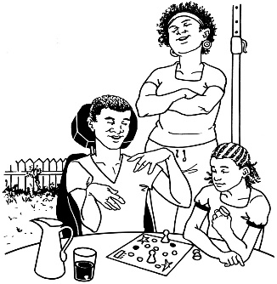
- somewhere people go during the day but do not stay at night.

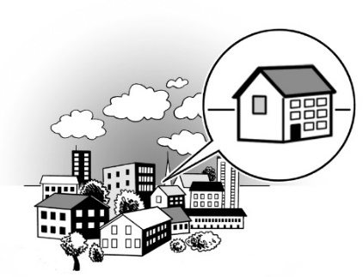
We will keep providing homes for Community Group Housing that are accessible for the people who use them.

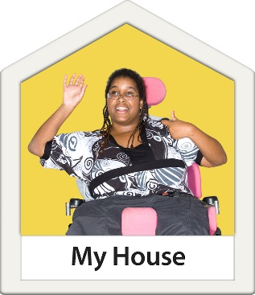
We also want to find other ways to assist people with lots of access needs to live independently.

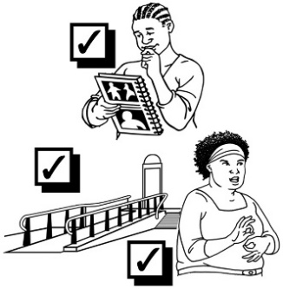
We will keep learning how to make homes that work for different groups of people.

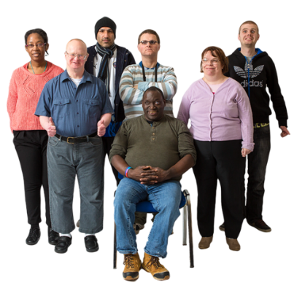
For example we will find out more about the kinds of modifications Deaf people need in their home.

- Get better information
?

What do our tenants need?
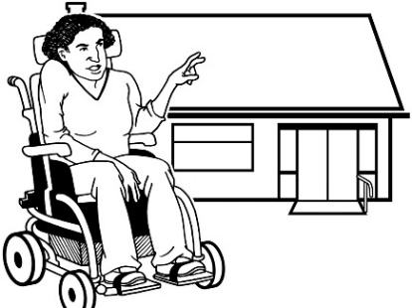
We need better information about what our tenants need to make their homes accessible.

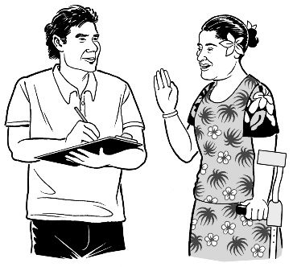
We will collect information from our tenants that:

- is up to date
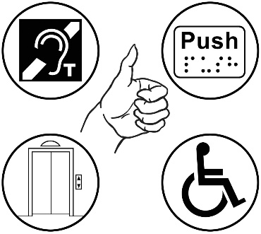
- tells us everything they need in a home.

This will help us:

- meet the needs of that tenant
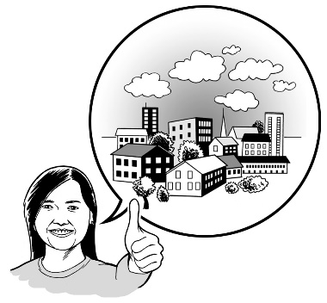
- understand what needs our housing will have to meet in the future.

How accessible are the homes we rent out?
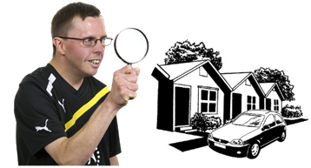
We need better information about the homes we rent out so that:
?
- we can find people homes that meet their needs

- we know if we have enough accessible housing.

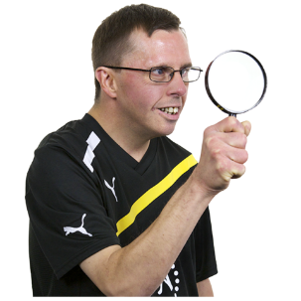
We will:

- find out what accessibility features our homes have

- keep this information in a way that is useful.

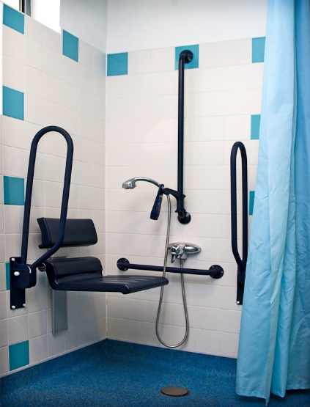
Accessibility features are things that make a home more accessible like:

- rails to hold on to

- rooms that are big enough for a wheelchair.

What you will see
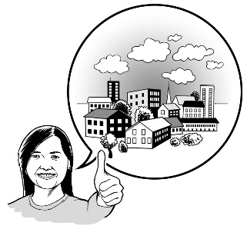
This is some of the important work that people outside of Kāinga Ora will be able to see:

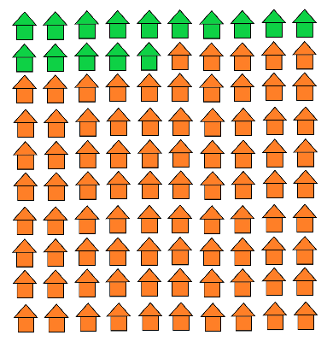
- Out of every 1 hundred new homes we build 15 homes or more will meet all of our Universal Design standards.

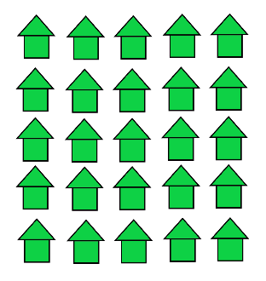
This number will probably go up in the future.

The rest of the new homes we build will meet as many of our Universal Design standards as possible.

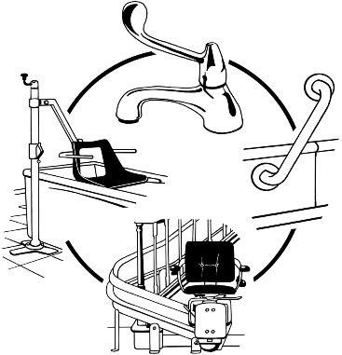
- We will support each tenant to live in a home that meets their needs.

If needed we will:
- make modifications to their home

- find a home that meets their needs better.

- We will look at how we can make our homes more accessible when they need other work done on them.

- We will get all the important information about how accessible our homes are.

This will mean we can find homes that meet the needs of our tenants.

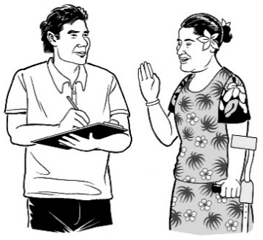
- We will get a better understanding of what our tenants need.

This will help us support the tenants:
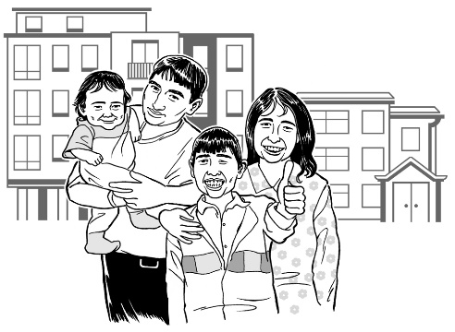
- we have now

- we will have in the future.

What happens when?
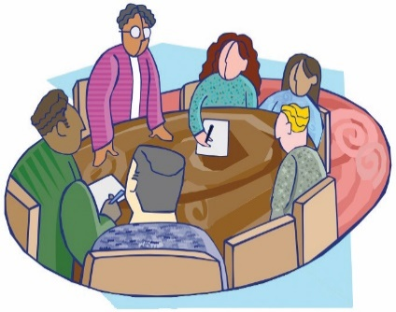
September 2019
The board of Housing New Zealand agreed to the Accessibility Policy.

The board is the group of people in charge of making sure an organisation is:

- doing a good job

- following the law.

October 2019
Housing New Zealand became part of Kāinga Ora.

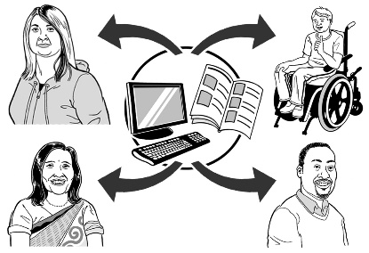
Near the end of 2019
Kāinga Ora will:

- share this Accessibility Policy with the public
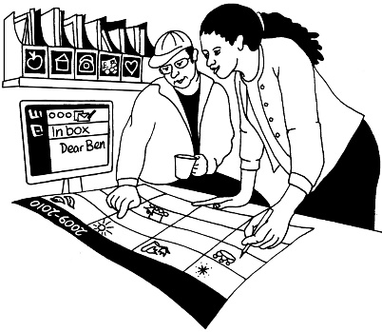
- start to do the work in the Accessibility Policy.

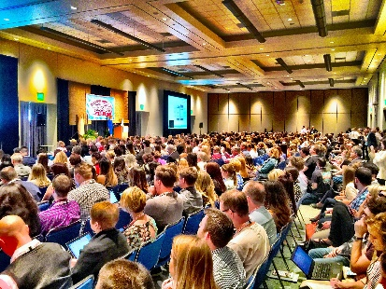
In 2020
We will have a big meeting that we call a Housing Accessibility Symposium.

We will tell people at the Housing Accessibility Symposium how the work in our Accessibility Policy is going.

From April 2020 to April 2021
We will:

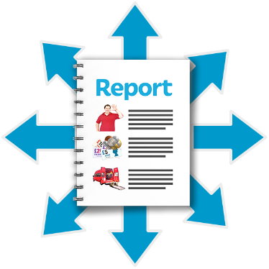
- keep a record of how many new homes we build that meet our Universal Design standards

- let other people know how many new homes we build that meet our Universal Design standards.

From April 2021 to April 2022
Out of every 1 hundred new homes we build 15 homes or more will meet all of our Universal Design standards.

This number will probably go up in the future.

Get in touch
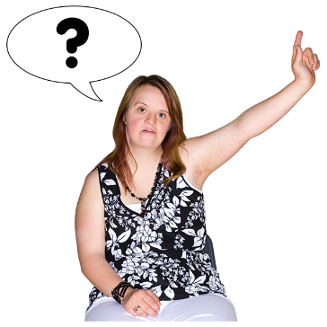
We would love to hear:

- your questions about our Accessibility Policy.
- your thoughts about our Accessibility Policy.

You can email us at:

accessibility@kaingaora.govt.nz

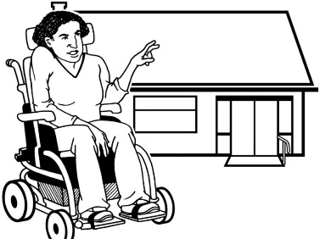
You can email us about anything to do with Kāinga Ora and accessibility.

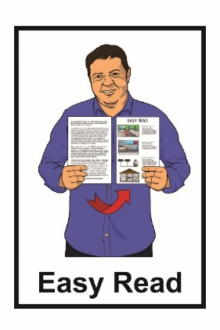
This information has been translated into Easy Read by the Make It Easy service of People First New Zealand Inc. Ngā Tāngata Tuatahi.

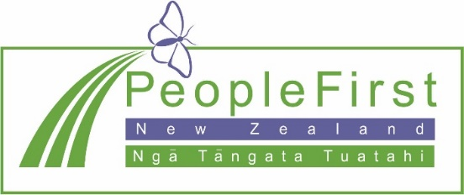
The ideas in this document are not the ideas of People First New Zealand Ngā Tāngata Tuatahi.

Make It Easy uses images from:
- Changepeople.org

- Photosymbols.com

- Sam Corliss
- Steve Bolton

