A short Easy Read introduction to our

Accessibility Policy
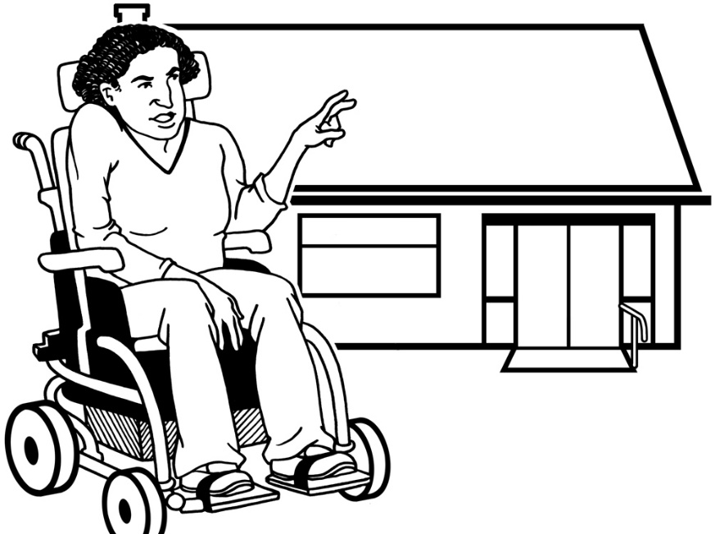

How Kāinga Ora will make more accessible homes
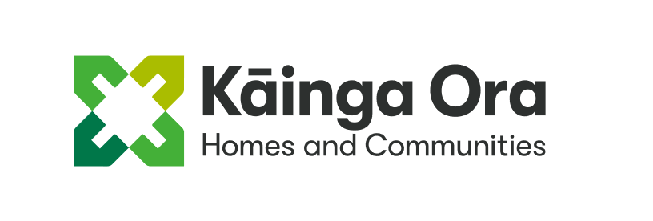
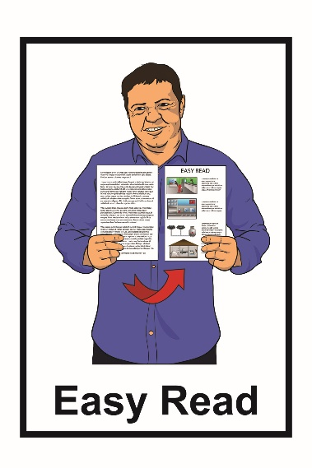

Who is Kāinga Ora?
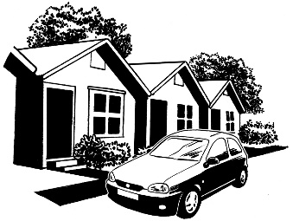
Kāinga Ora is the new government agency that works on housing.

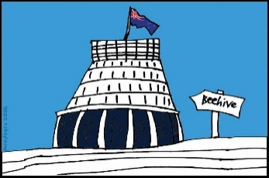
A government agency is a group that does work for the government.

Kāinga Ora does the things that Housing New Zealand used to do like:
- building homes

- owning homes
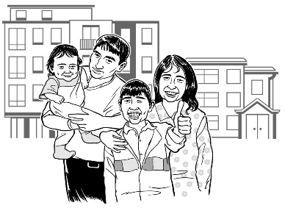
- renting homes to people who need them.

What is this document about?
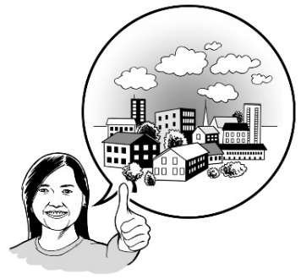
This is a short introduction to how Kāinga Ora will work to make the homes we rent out more accessible.

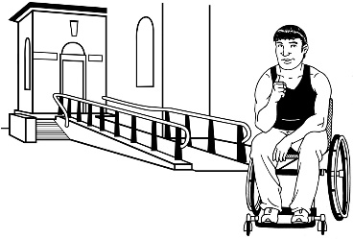
If something is accessible it means people with disabilities are able to use it.

In this document you can read about:

- the things we want to happen
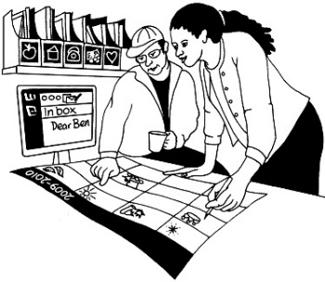
- the work we will do to make these things happen.

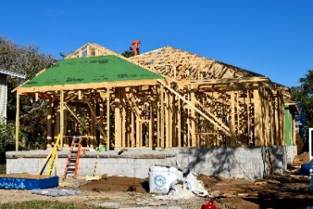
The work we will do includes:

- building new homes
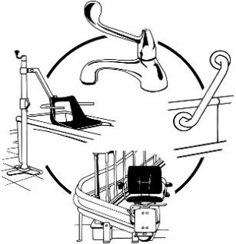
- changing old homes to make them more accessible.

Things we want to happen
We have 3 main outcomes.

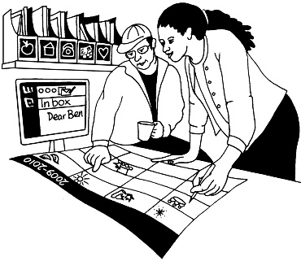
Outcomes are the things we will work to make happen.

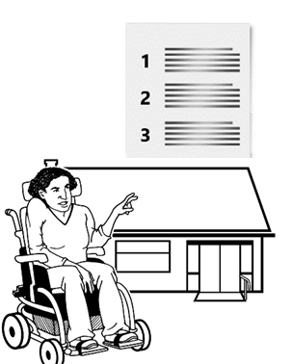

Outcome 1

More of our homes meet our Universal Design standards.

Universal Design is about making things accessible to as many people as possible.
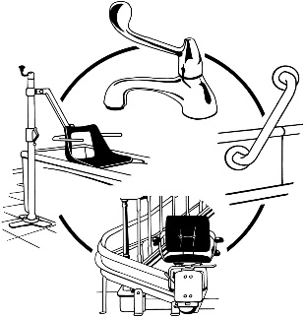
Universal Design is also about making things that can be changed if they need to be.
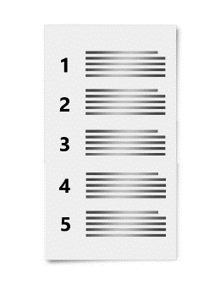
Using the idea of Universal Design we made a list of things that make a home accessible.

Our Universal Design standards are the things on this list.

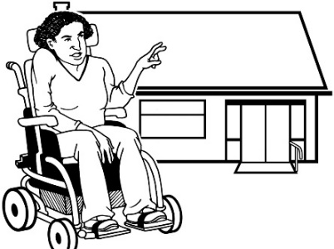

Outcome 2

Meet the different needs of each tenant.

The people who rent homes from Kāinga Ora are called our tenants.

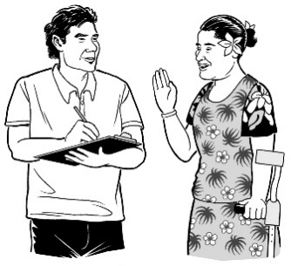
Outcome 3

Get better information about:

- What do our tenants need?
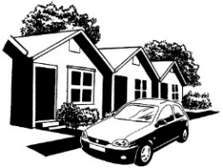
- How accessible are the homes we rent out?

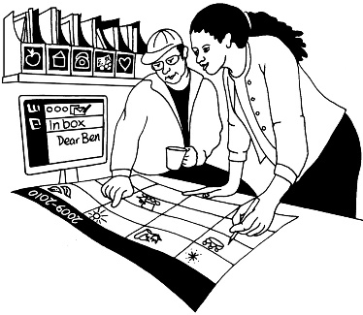
On the next pages we say what work we will do to make each outcome happen.

More of our homes meet Universal Design standards

Universal Design standards
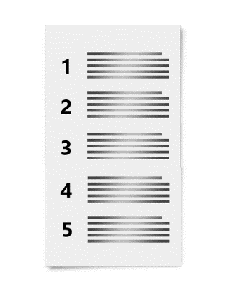
We have a list of things that will make a home accessible.
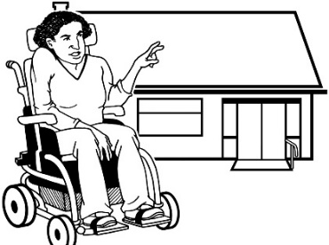
Universal Design standards are the things on this list.

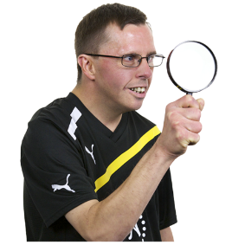
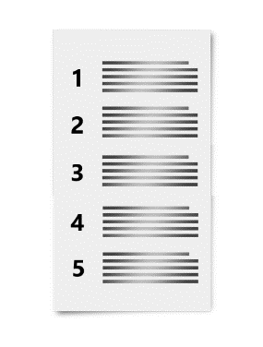
We will look at our Universal Design standards to see if anything needs to change.

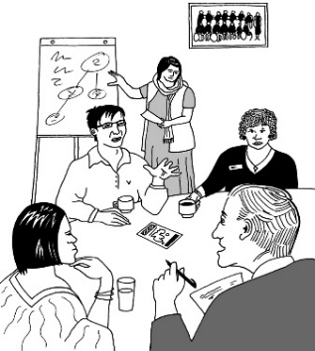
We will explain our Universal Design standards to the people who need to use them.

Building new homes
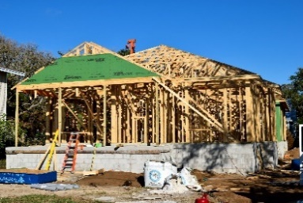
We will make more new homes that meet our Universal Design standards.

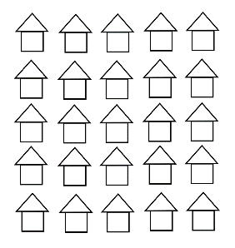
We will:

- say how many of our new homes will meet all the Universal Design standards
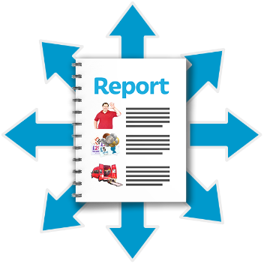
- let people know if we made this many new homes.

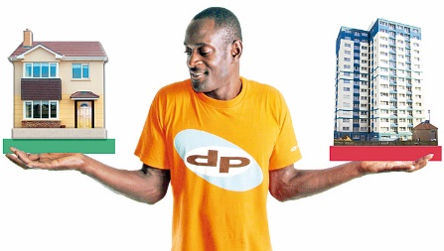
We will make sure that we make different kinds of homes that meet the Universal Design standards.

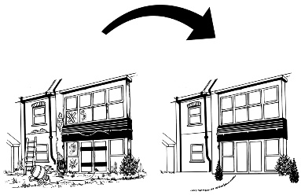
Homes that are already made

Many of the homes that Kāinga Ora rents out need work done on them.

When we work on these homes it will be a chance to make them more accessible.

We want to find out:

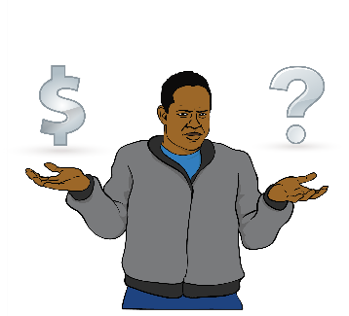
- How hard is it to make these homes meet our Universal Design standards?

- How much money will it cost?

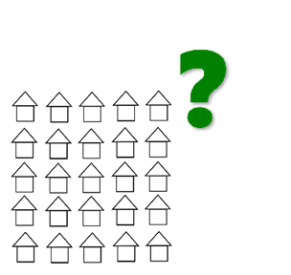
When we have answers we will make a plan that says how many homes we will make more accessible.

Meet the different needs of each tenant

Modifications to a Kāinga Ora home

Modifications are changes that make a home more accessible.

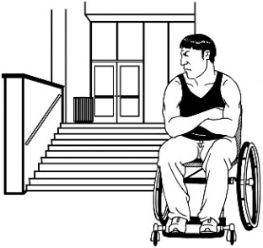
When a tenant needs modifications to their home we assist them to ask for money from:
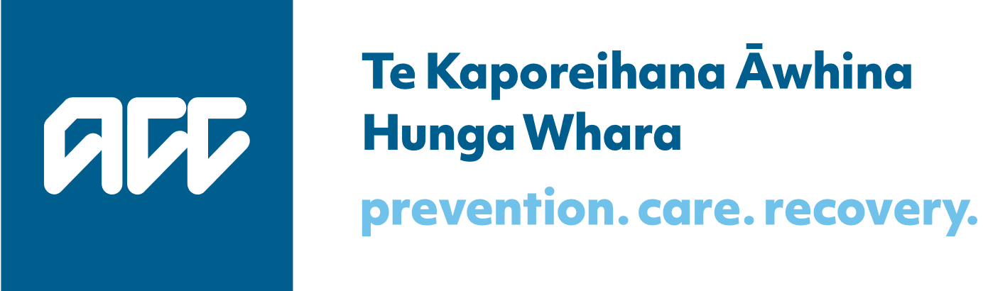
- ACC

or
- the Ministry of Health.

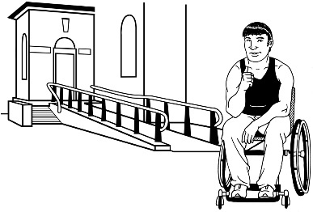
Then Kāinga Ora make the changes.

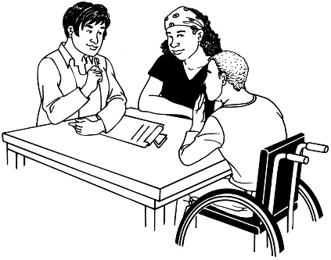
We will work with ACC and the Ministry of Health to make it easier to ask for money for modifications.

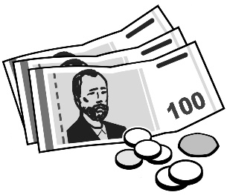
We will also look into ways that Kāinga Ora can pay for modifications.

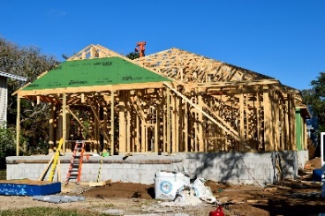
Sometimes the best thing is for a tenant to move into a new home that is made to meet their needs.

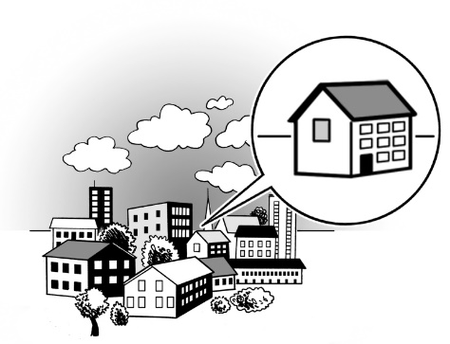
Homes for groups of people with the same needs

Kāinga Ora rents out some of our homes to other organisations to use for Community Group Housing.

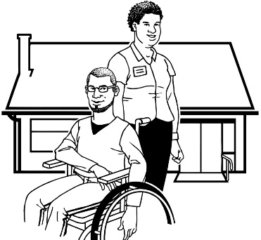
Community Group Housing is for groups of people like:

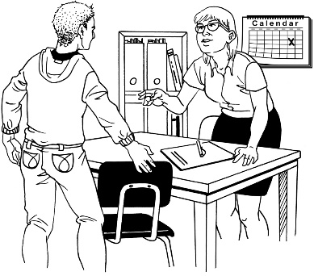
- disabled people who need assistance

- young people who need extra support

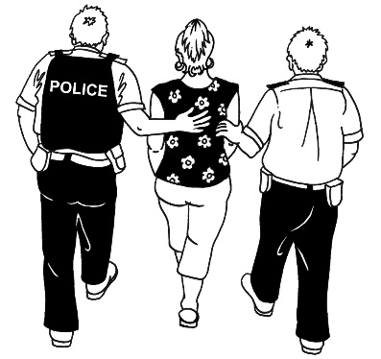
- people who have just got out of prison.

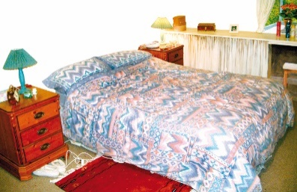
Community Group Housing can be:

- somewhere people live
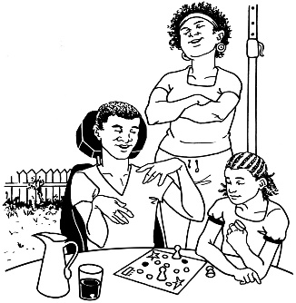
- somewhere people go during the day but do not stay at night.

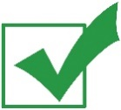
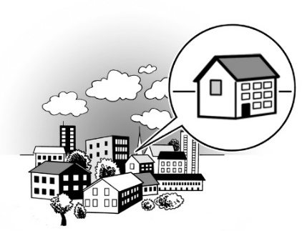
We will keep providing homes for Community Group Housing that are accessible for the people who use them.

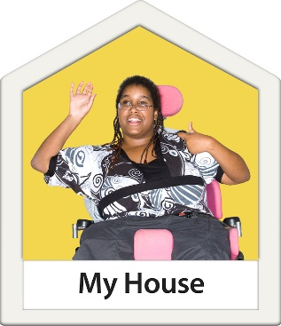
We also want to find other ways to assist people with lots of access needs to live independently.

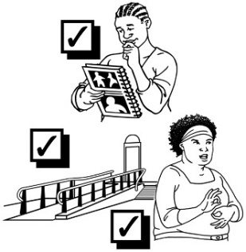
We will keep learning how to make homes that work for different groups of people.

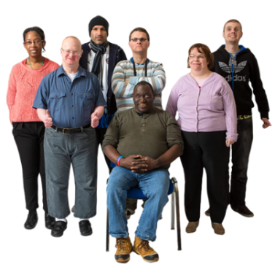
For example we will find out more about the kinds of modifications Deaf people need in their homes.

Get better information
?

What do our tenants need?
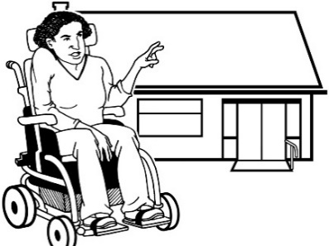
We need better information about what our tenants need to make their homes accessible.

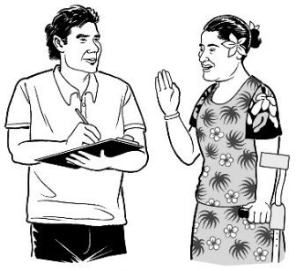
We will collect information from our tenants that:

- is up to date
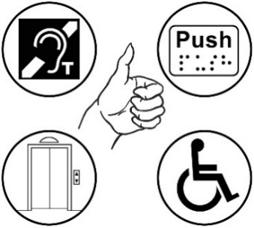
- tells us everything they need in a home.

This will help us:

- meet the needs of that tenant
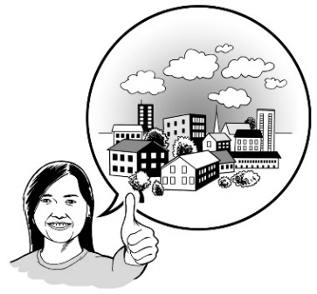
- understand what needs our housing will have to meet in the future.

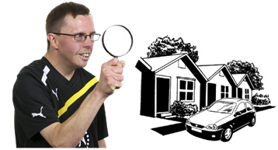
How accessible are our homes?

We need better information about the homes we rent out so:
?
- we can find people a home that meets their needs

- we know if we have enough accessible housing.

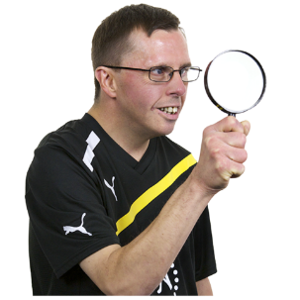
We will:

- find out what accessibility features our homes have

- keep this information in a way that is useful.

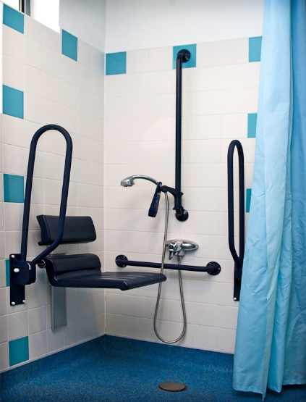
Accessibility features are things that make a home more accessible like:

- rails to hold on to

- rooms that are big enough for a wheelchair.

Find out more
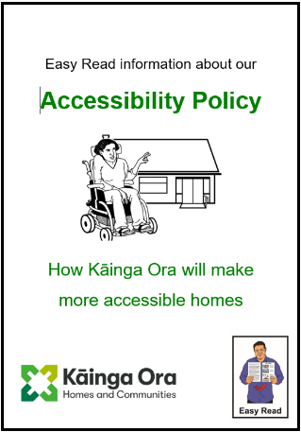
You can find more Easy Read information about our Accessibility Policy on this web page:

https://kaingaora.govt.nz/news/new-kainga-ora-accessibility-policy
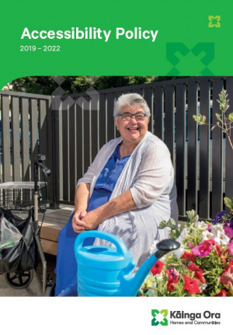

You can also find our full Accessibility Policy on that webpage.

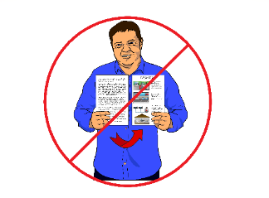
Our full Accessibility Policy is not in Easy Read.

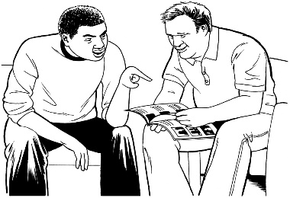
You may need someone to assist you to read it.

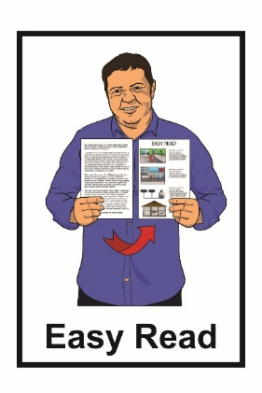
This information has been translated into Easy Read by the Make It Easy service of People First New Zealand Inc. Ngā Tāngata Tuatahi.

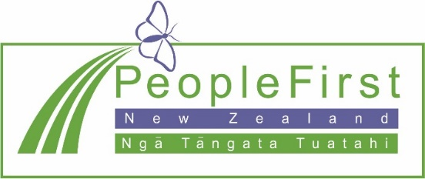
The ideas in this document are not the ideas of People First New Zealand Ngā Tāngata Tuatahi.

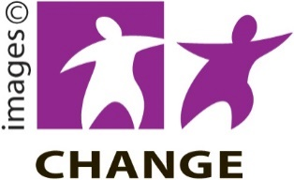
Make It Easy uses images from:
- Changepeople.org

- Photosymbols.com

- Sam Corliss
- Steve Bolton

